ONLINE EXAM PORTAL
@CREATIVITY THINK (9483175986/7019689991)

ABSTRACT:
The Online Exam Portal is a web-based application designed to facilitate exam and quiz management for schools, training centers, and certification platforms. The system allows students to register, participate in scheduled exams, and receive instant grades while providing administrators with comprehensive tools to schedule exams, manage question banks, and review performance analytics. Built using Django and Django REST Framework for backend processes and React with Axios and PDFKit on the frontend, the platform offers a secure, scalable, and automated solution for online assessment management..

INTRODUCTION OF THE PROJECT:
Traditional exam systems often involve manual scheduling, paper-based tests, and time-consuming grading, which leads to inefficiencies and delayed feedback. The Online Exam Portal addresses these issues by providing a digital solution where exams and quizzes can be scheduled, auto-graded, and monitored in real time. Students can access a personalized dashboard with performance analytics, while administrators gain insight into student performance and overall platform usage. The system ensures fairness, transparency, and efficient management of online assessments..

PROJECT OBJECTIVES:

• Provide a secure platform for scheduling and taking exams.
• Maintain a centralized question bank for automated assessment.
• Enable auto-grading and instant result generation for students.
• Offer dashboards for students to track their performance over time.
• Allow administrators to schedule exams and quizzes efficiently.
• Provide analytical tools for performance evaluation and reporting.
• Enable exporting of results and analytics in PDF format.
• Ensure scalability for schools, training centers, and certification platforms.

PROBLEM OF THE STATEMENT:
Manual and semi-digital exam systems face challenges such as delayed grading, lack of centralization, limited tracking of student performance, and difficulty in analytics. Students and administrators lack tools for real-time assessment and reporting. The Online Exam Portal solves these problems by automating exam delivery, grading, and analytics, thereby improving efficiency, transparency, and reliability of assessments..

MOTIVATION OF THE PROJECT:
• To replace paper-based and manual assessment methods.
• To provide students instant feedback and performance tracking.
• To reduce administrative workload and eliminate grading errors.
• To create a centralized question bank for multiple exams.
• To provide actionable insights for teachers and administrators.
• To support online learning and certification workflows efficiently.

BLOCK DAIGRAM OF PROJECT:

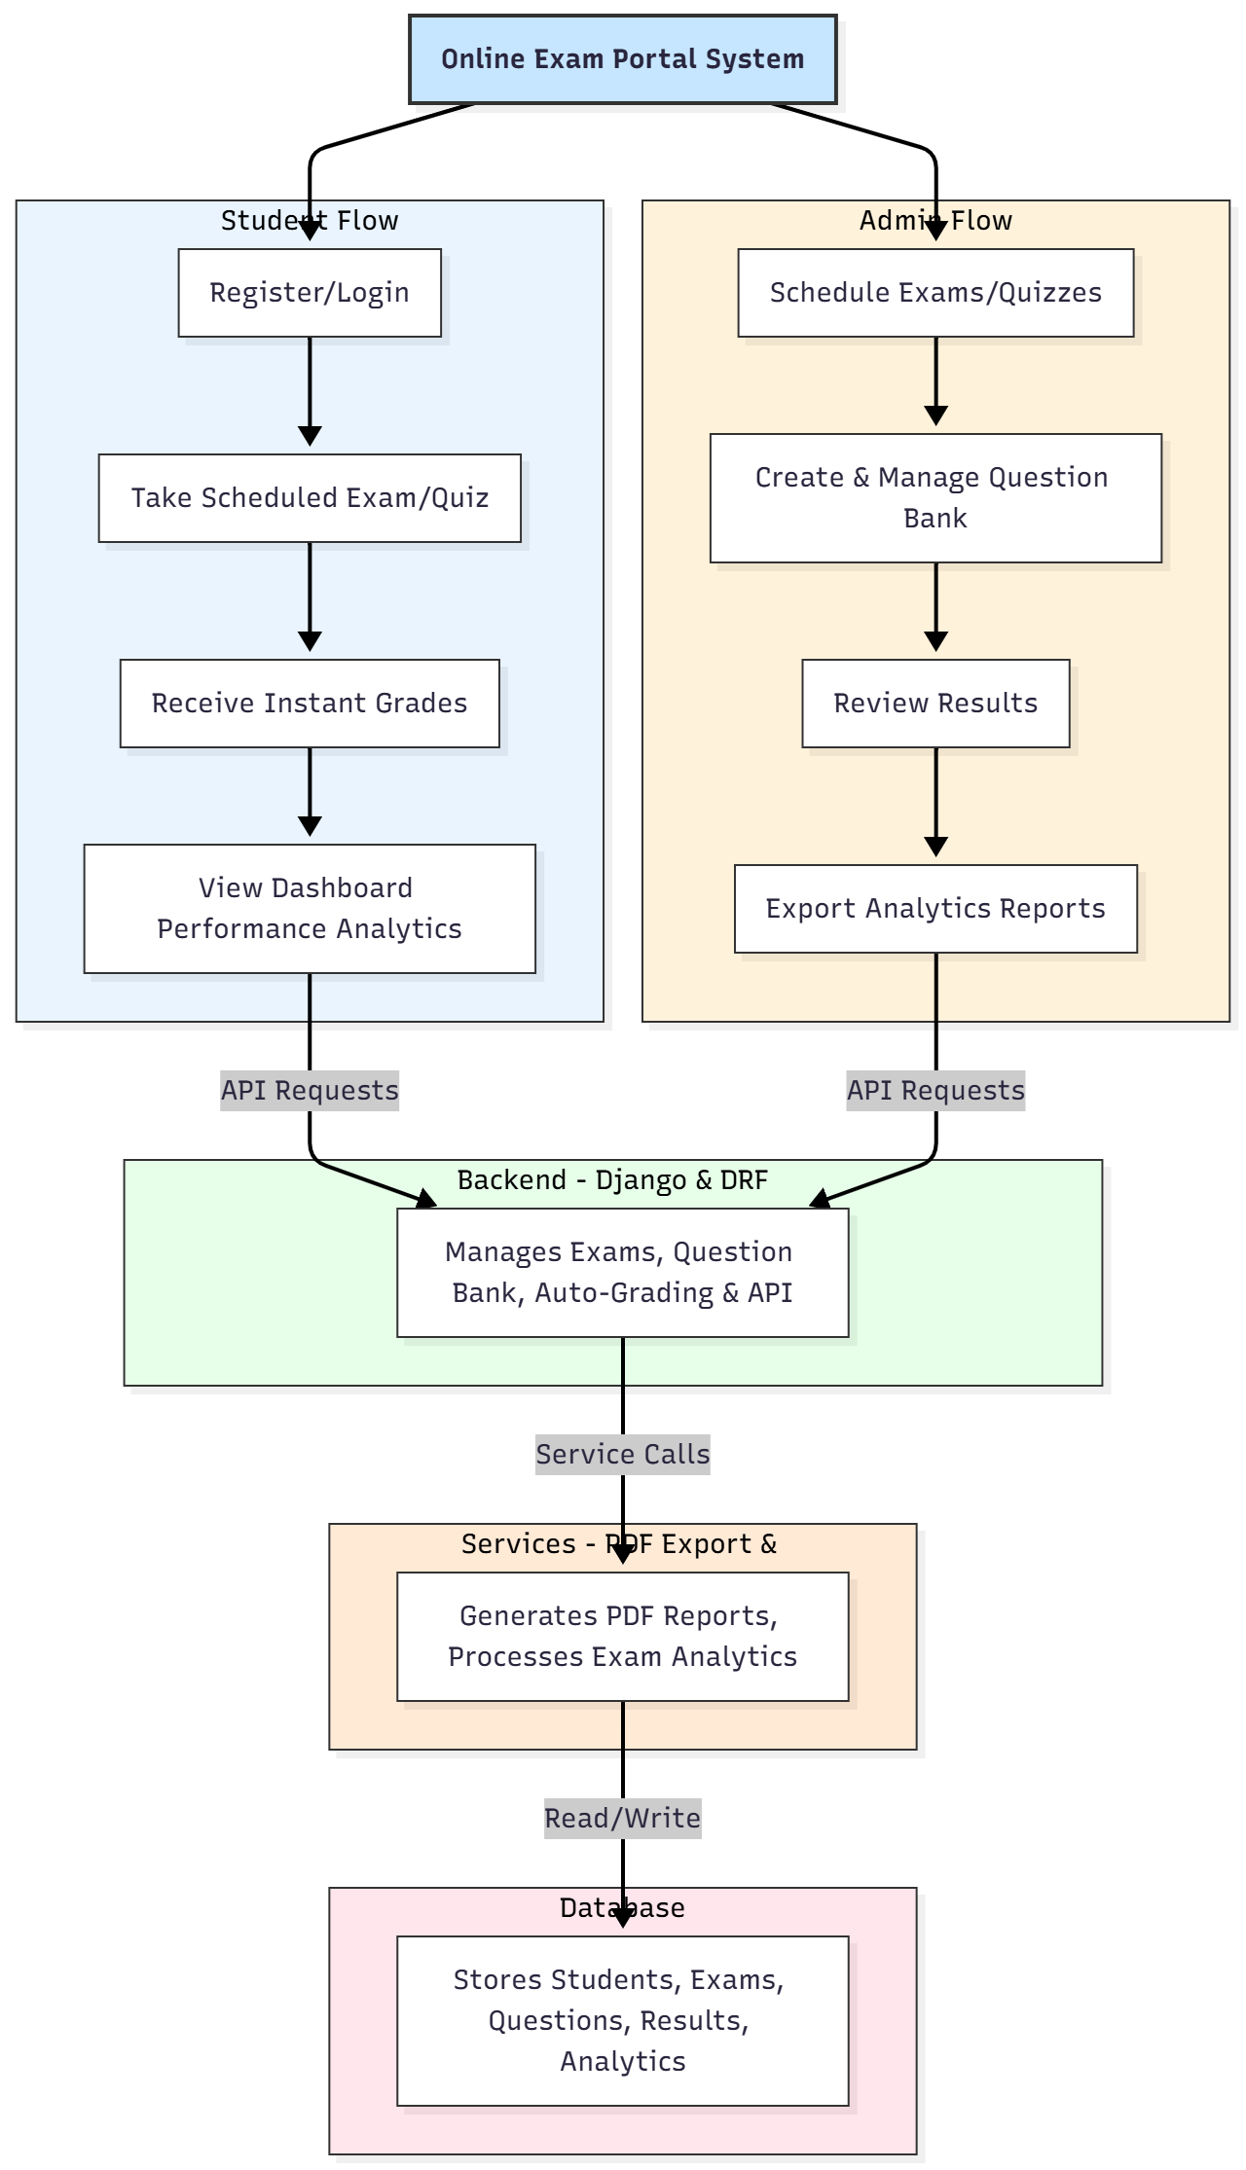

WORKING OF THE PROJECT:
Students first register or log into the system. After authentication, they access scheduled exams or quizzes from their dashboard. Upon completion, the backend automatically grades submissions and updates the student’s dashboard with instant results. Administrators schedule exams, create and maintain the question bank, review student performance, and export analytics reports in PDF format using PDFKit. The backend ensures secure data handling, auto-grading, and consistent performance logging, while the frontend provides responsive UI with real-time updates..

SOFTWARE REQUIREMENT:
- Backend:
  - Python 3.x
  - Django
  - Django REST Framework
  - SQLite/PostgreSQL
- Frontend:
  - Node.js and npm
  - React.js
  - Axios
- Development Tools:
  - Visual Studio Code
  - Postman (for testing APIs)
  - Git/GitHub (for version control)
- Server/Deployment (Optional):
  - Gunicorn, Nginx, or Heroku/AWS for hosting

ADVANTAGES OF THE PROJECT:

• Automated exam scheduling and grading.
• Real-time performance tracking for students.
• Centralized question bank management.
• Detailed dashboards for both students and admins.
• Exportable analytics reports in PDF format.
• Reduces administrative errors and workload.
• Supports scalable deployment for schools and training centers.
• Enhances transparency and fairness in online assessment.

APPLICATIONS OF THE PROJECT:
• Schools and educational institutions
• Online training and certification platforms
• Skill assessment centers
• Coaching and tutoring centers
• Corporate employee training assessments
• Competitive exam practice portals

REFERENCES:

- Django REST Framework Documentation — Django Software Foundation. Django Documentation. Available: https://docs.djangoproject.com/
- Django REST Framework. DRF Documentation. Available: https://www.django-rest-framework.org/
- React. React Official Documentation. Available: https://reactjs.org/docs/getting-started.html
- Redux. Redux Documentation. Available: https://redux.js.org/introduction/getting-started
- PostgreSQL Global Development Group. PostgreSQL Documentation. Available: https://www.postgresql.org/docs/
- MySQL. MySQL Reference Manual. Available: https://dev.mysql.com/doc/
- Git. Git Documentation. Available: https://git-scm.com/doc
- Node.js. Node.js Documentation. Available: https://nodejs.org/en/docs/
- Axios. Axios Documentation. Available: https://axios-http.com/docs/intro
- Socket.io Documentation – https://socket.io/docs/

